Incident Response Team Exercise

Contents

IRT Exercise Observation 3

1. Screenshot(s) of ping results showing attempted connection(s) with the attack target(s) 3

2. Notes and screenshots verifying attack attempts and types of incidents 4

2.1 Nessus Vulnerability Scan 4

2.2 Port Scanning 6

2.3 Directory Busting 9

2.4 Spidering 12

2.5 Brute Force Attack 15

2.6 Post-Exploitation Enumeration 17

2.7 Privilege Escalation 23

2.8 Blue Team Observation Checklist 26

## IRT Exercise Observation

Red team: Andrew Negapatan, Md Salam  
Observed by: Blue team – Md Salam, Andrew Negapatan, Nickolai Balida  
Date: 06/11/2025

### 1. Screenshot(s) of ping results showing attempted connection(s) with the attack target(s)

Nmap on network 10.30.0.0/24 to get IP address of Blackbox Host (10.30.0.250) and then Ping from Red Team Kali Host (192.168.1.27)

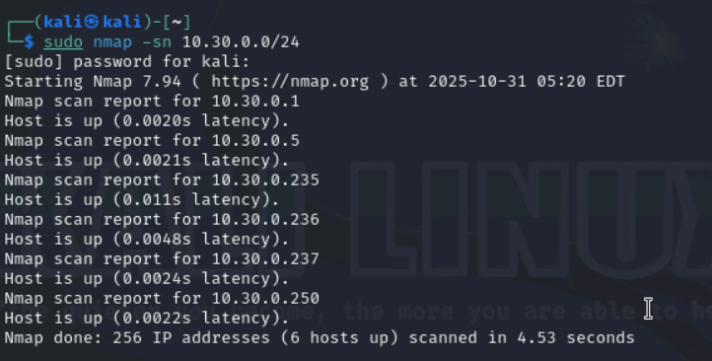

To Metasploitable (10.30.0.235) and Windows Server (10.30.0.236)

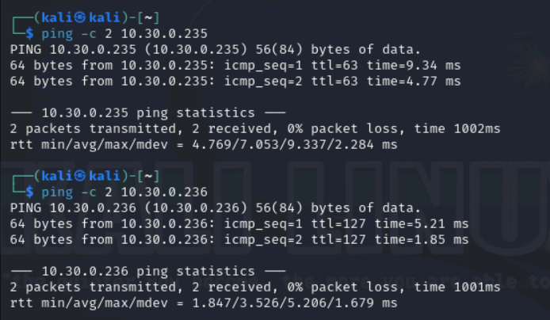

To Web Servers Farm (10.30.0.237) and Blackbox Host (10.30.0.250)

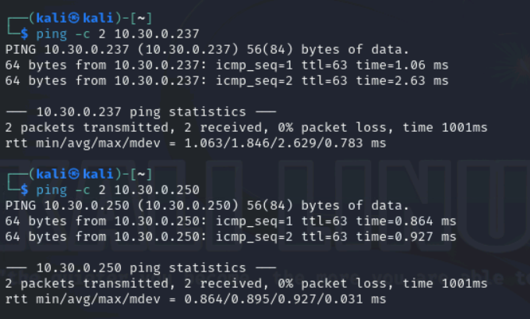

## 2. Notes and screenshots verifying attack attempts and types of incidents

### 2.1 Nessus Vulnerability Scan

Red Team Activity:

The red team conducted a vulnerability assessment across all target hosts within the DMZ using Nessus to systematically identify known security weaknesses that could be exploited by attackers. This process enabled the organisation to evaluate its current security posture and prioritise remediation efforts to address the identified vulnerabilities.

Target: 10.30.0.235 (Metaspoitable), 10.30.0.236 (Windows Server), 10.30.0.237 (Web Servers Farm), 10.30.0.250 (Black Box)

The scan report will be provided at the end of the project.

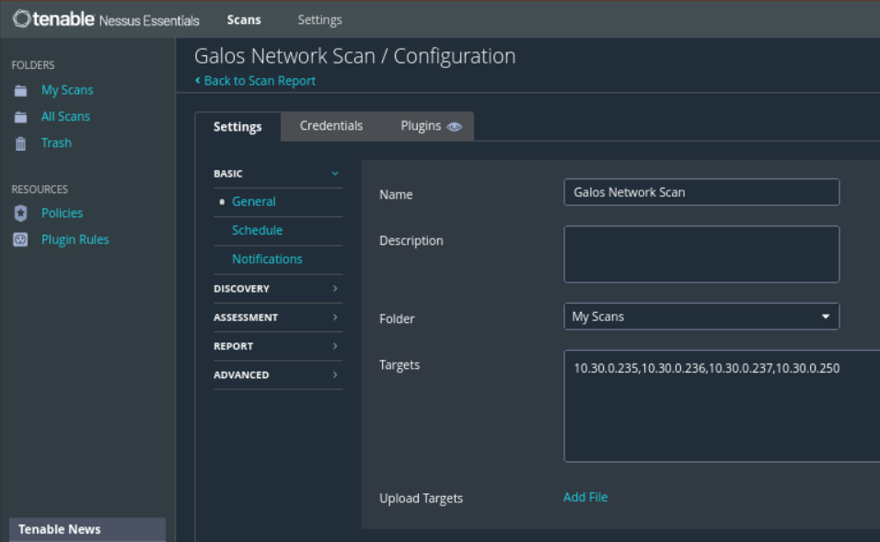

Blue Team Activity:

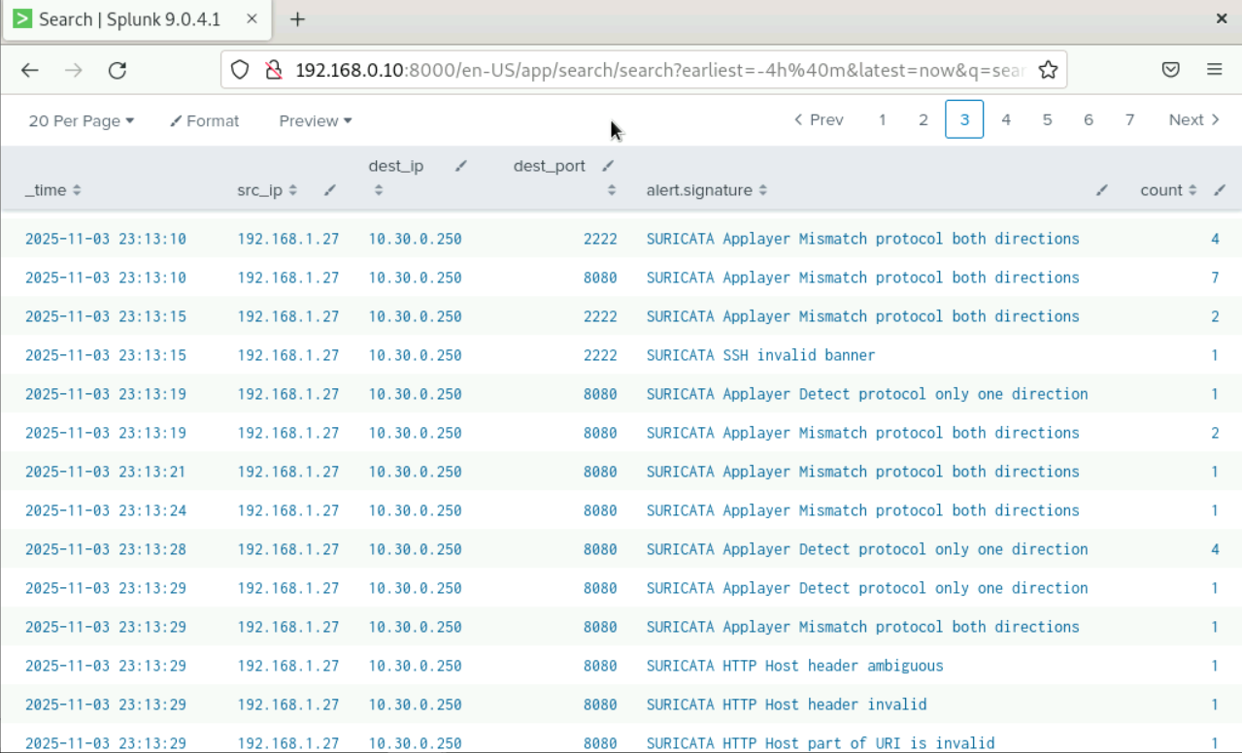

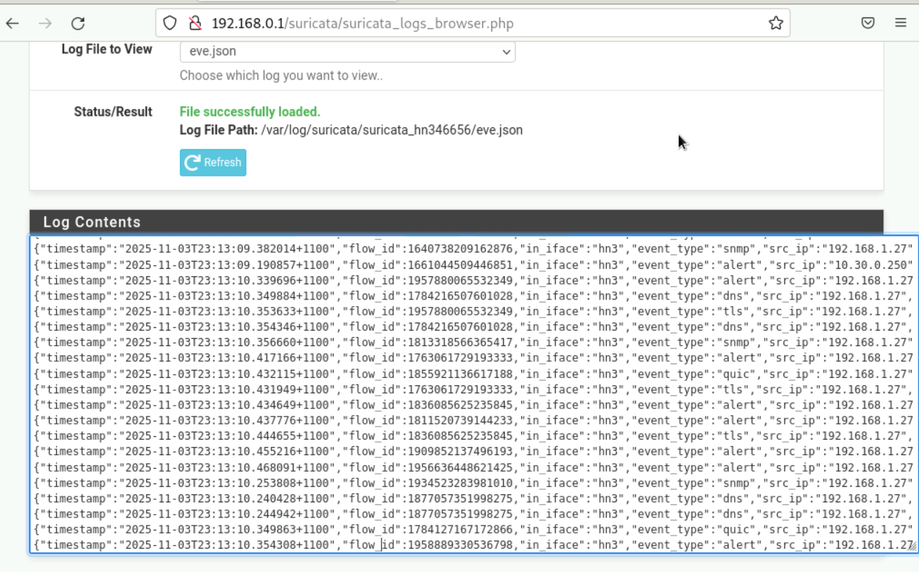

From Splunk and pfSense Suricata, we were able to monitor the Nessus vulnerability scanning activities as shown above.

### 2.2 Port Scanning

Red Team Activity:

The red team performed Nmap port scanning on the Blackbox host to identify open ports, live hosts, and active services within the target network.

Target: 10.30.0.250

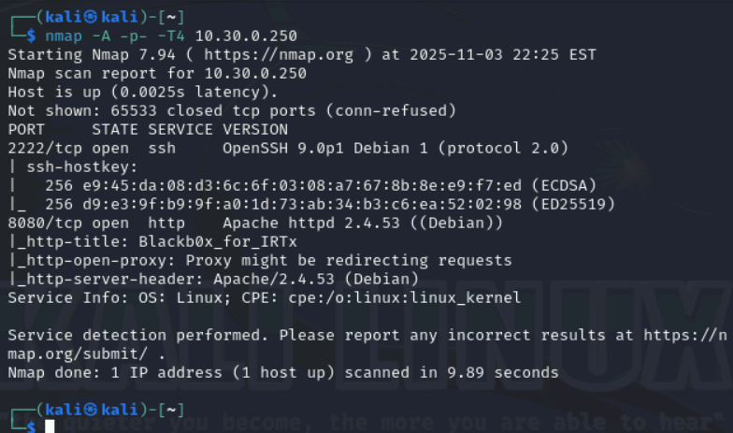

Blue Team Activity:

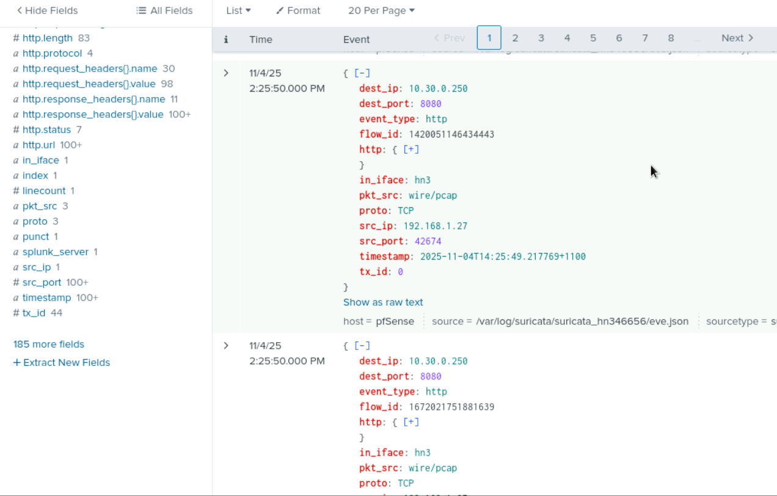

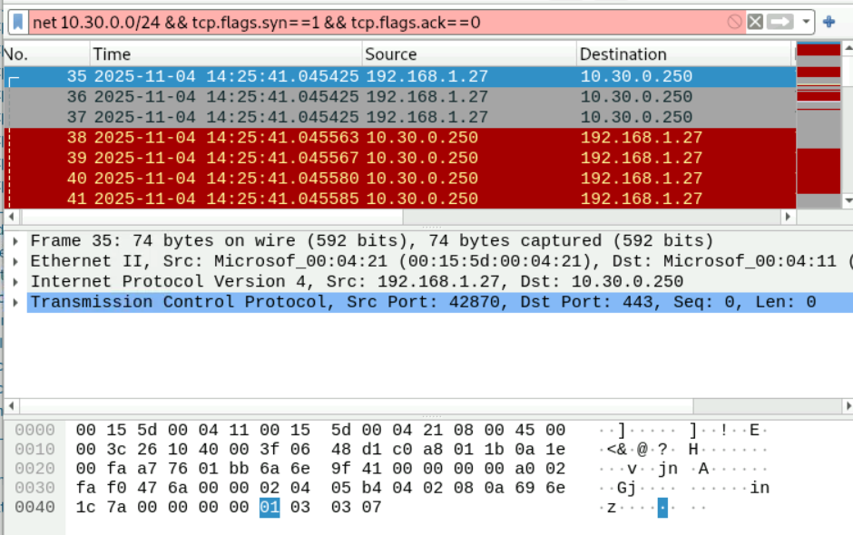

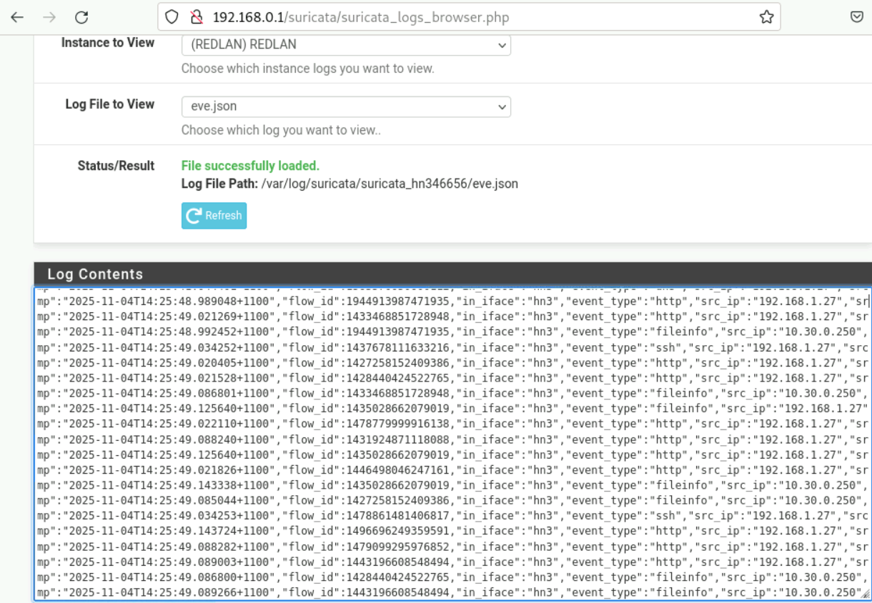

We detected port-scanning activity using Splunk, Wireshark and pfSense suricata indicating a potential hacking attempt.

### 2.3 Directory Busting

Red Team Activity:

The red team launched web content scanning to identify hidden web content, directories, files, and potential vulnerabilities within the target web application.

Target: 10.30.0.250

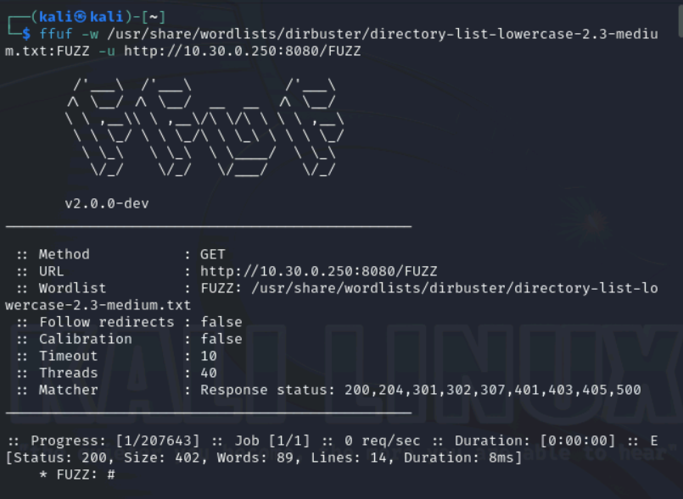

Blue Team Activity:

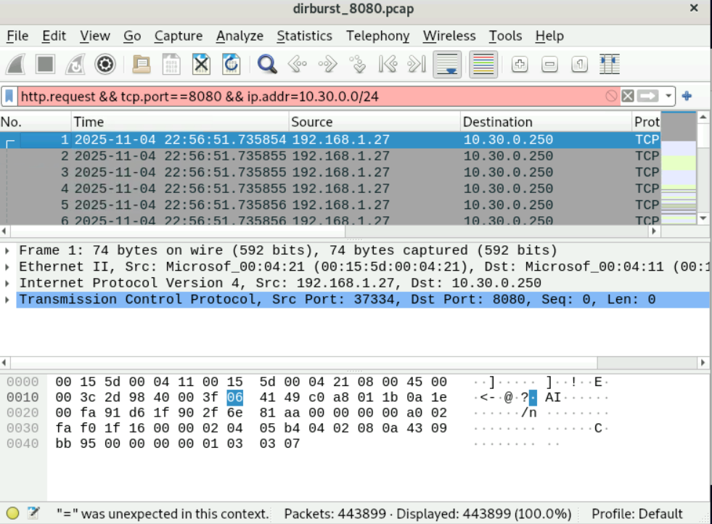

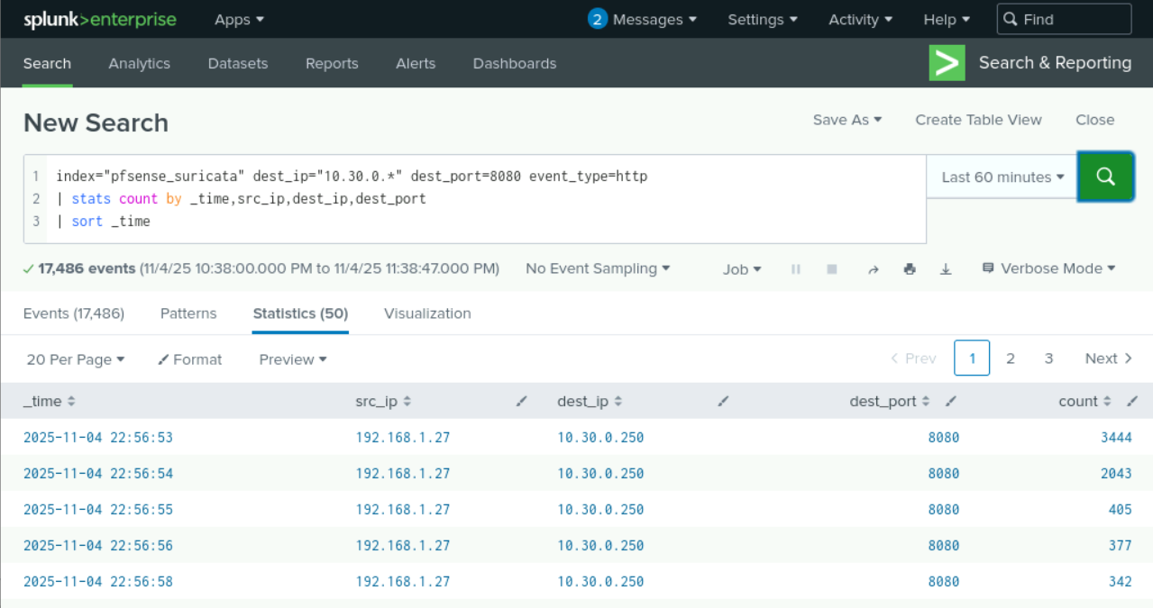

We were able to monitor this suspicious activity of web content scanning from Wireshark and Splunk. At this stage, we may have to report to a team supervisor on this potential hacking attempt.

### 2.4 Spidering

Red Team Activity:

The red team performed web spidering to map the structure of the target web application, uncover hidden or unlinked content, and identify potential vulnerabilities. The scan successfully located *robots.txt* file containing hints for a username and password.

Target: 10.30.0.250

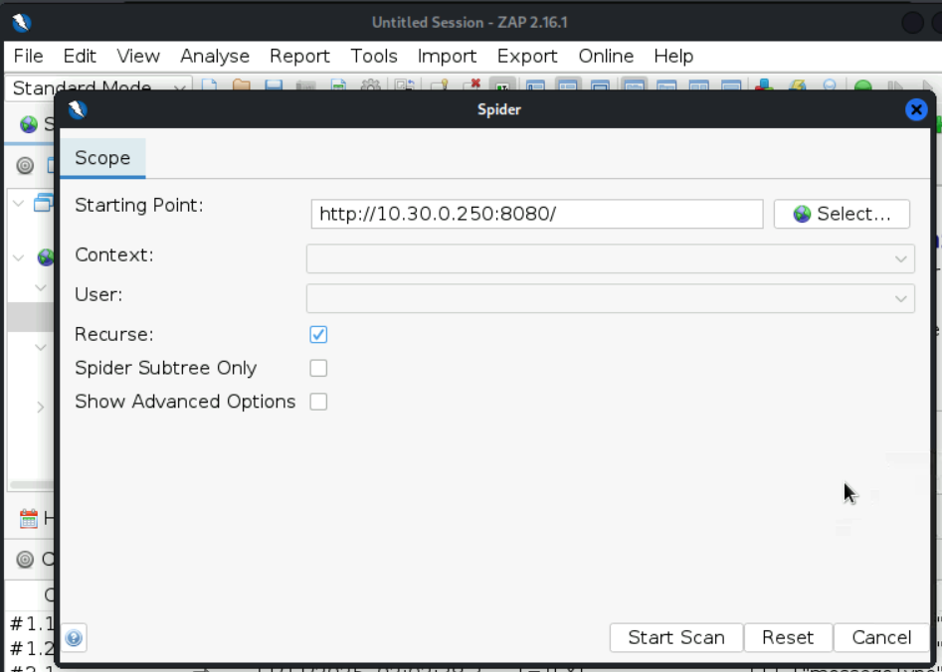

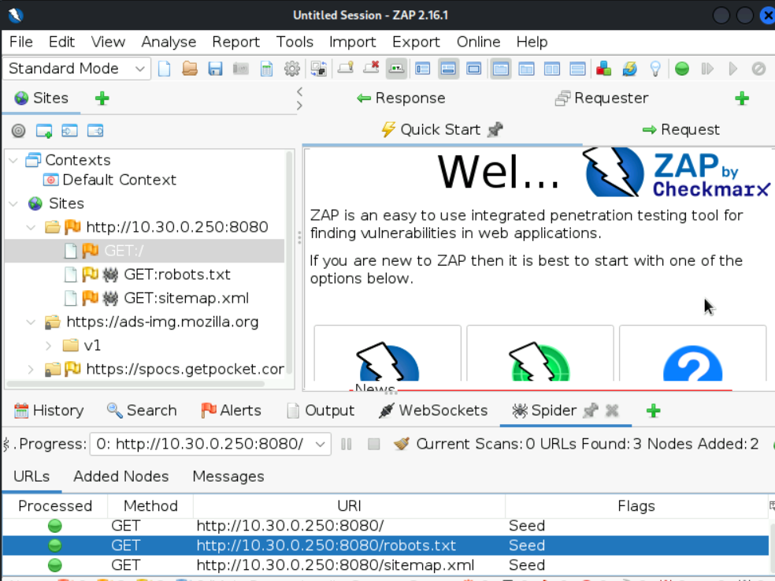

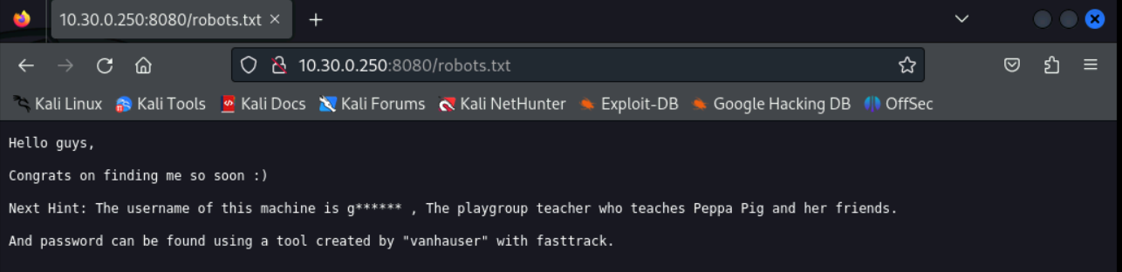

Blue Team Activity:

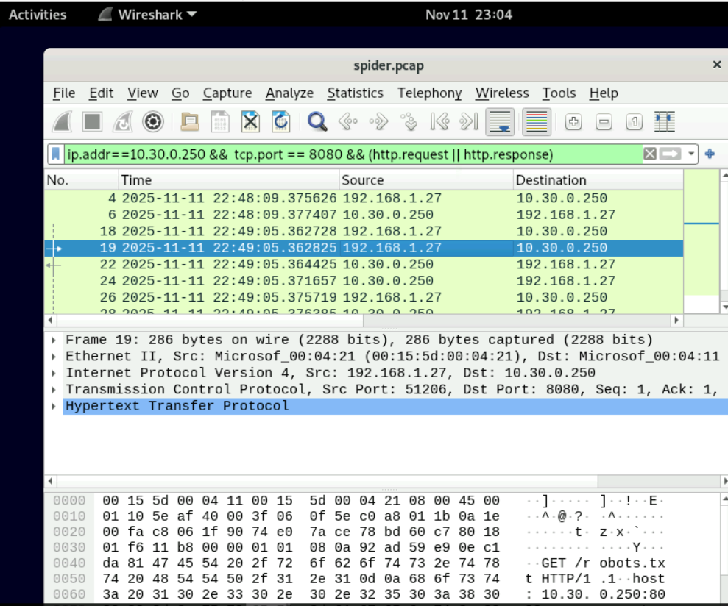

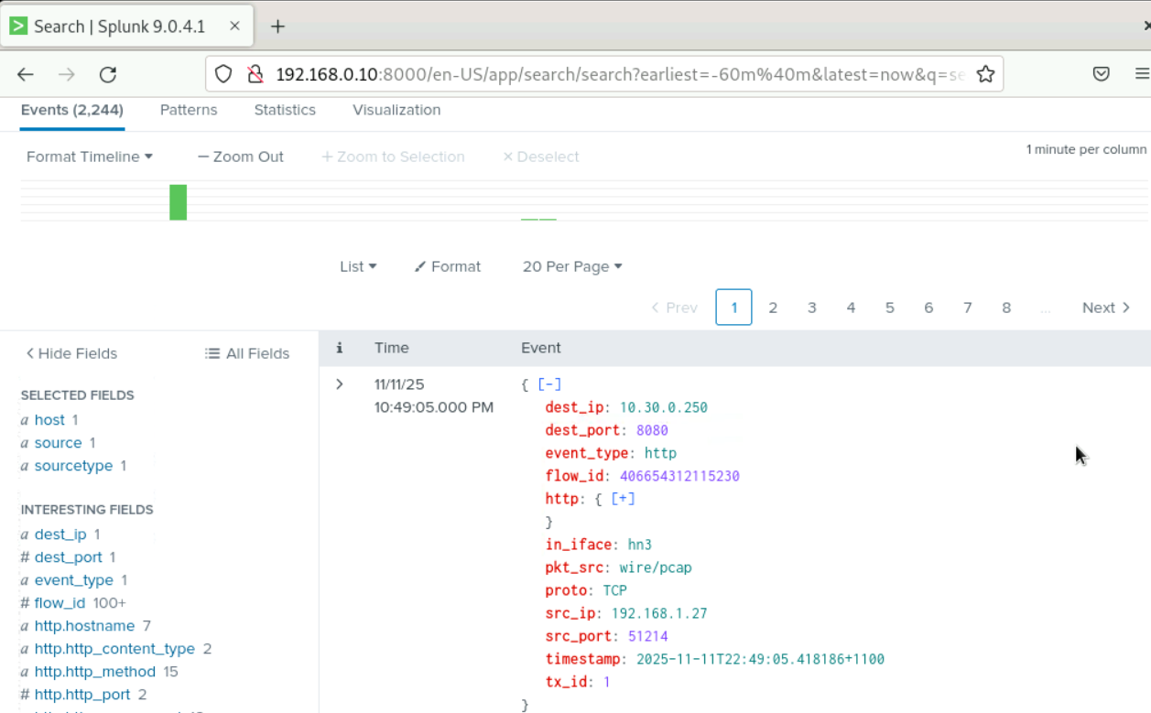

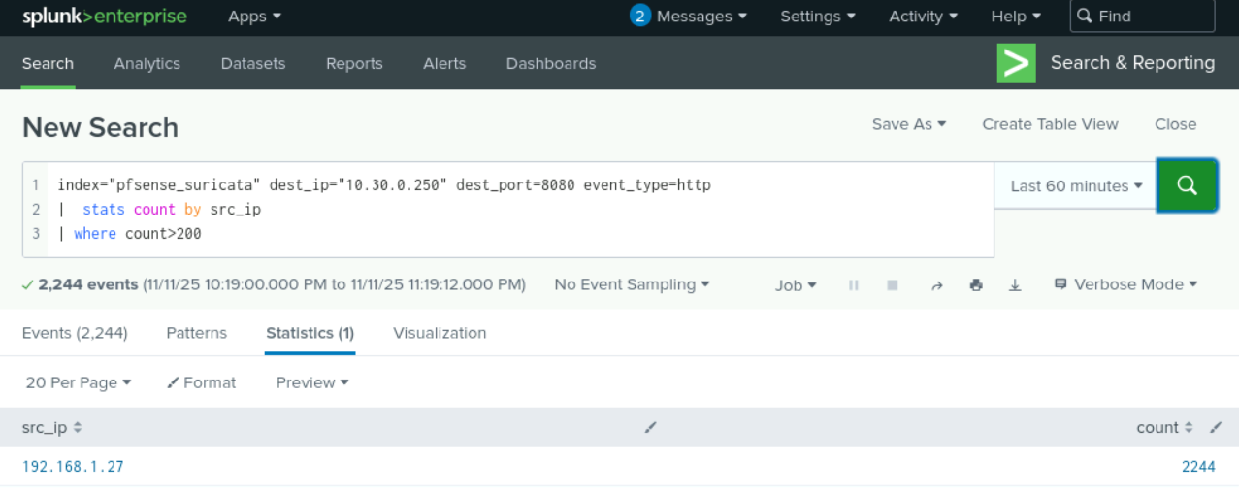

We were able to monitor this spidering activity via Wireshark and Splunk.

### 2.5 Brute Force Attack

Red Team Activity:

The red team conducted a brute force attack on the target system to gain unauthorised access by systematically attempting multiple password combinations until a valid one was found. The attack was successful, and the team obtained the correct password.

Target: 10.30.0.250

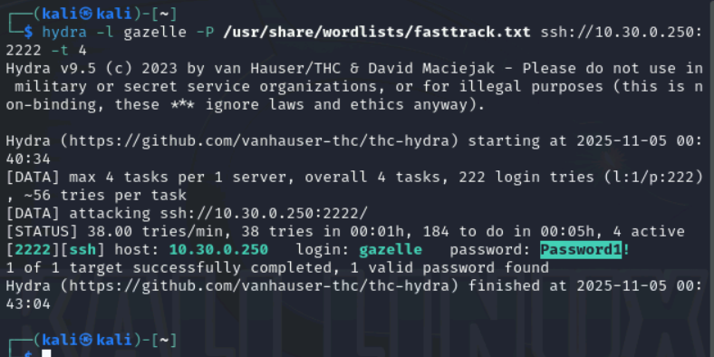

Blue Team Activity:

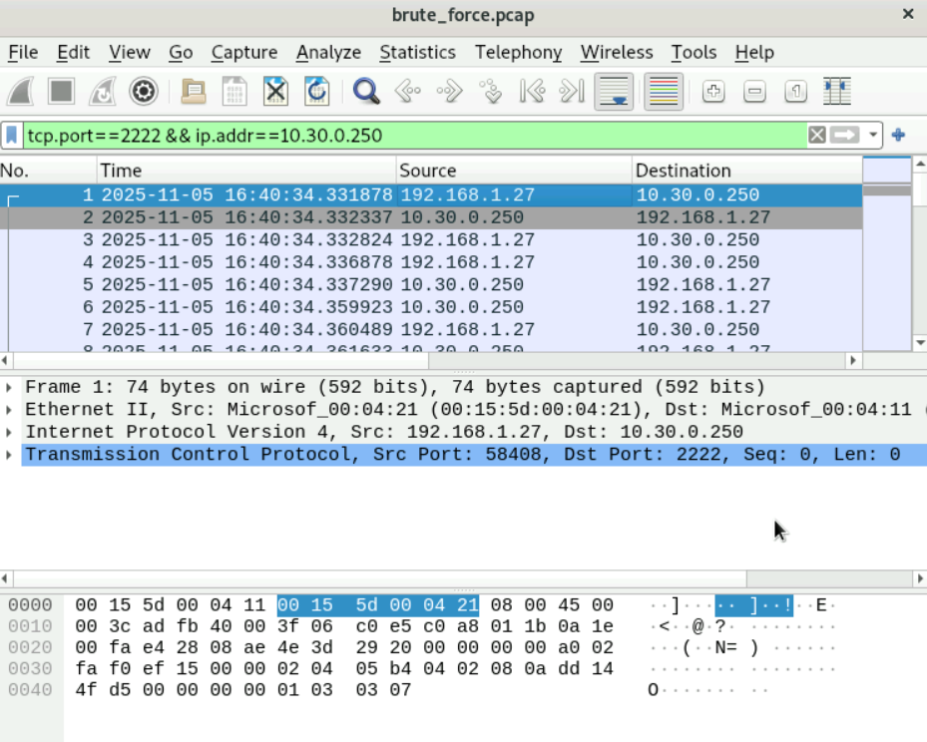

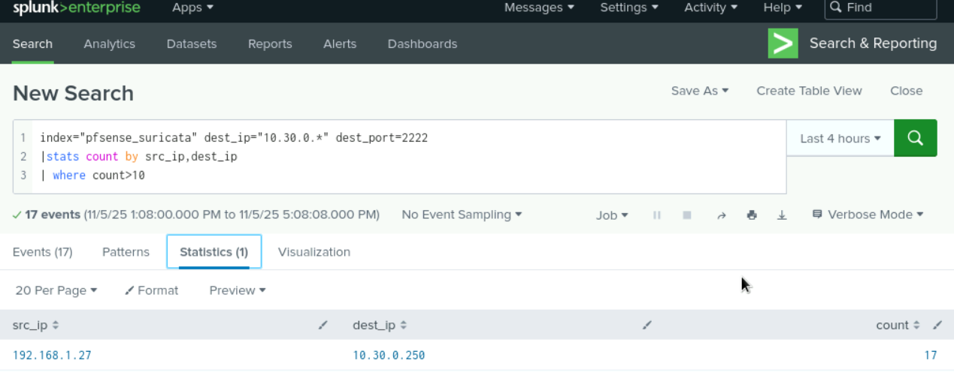

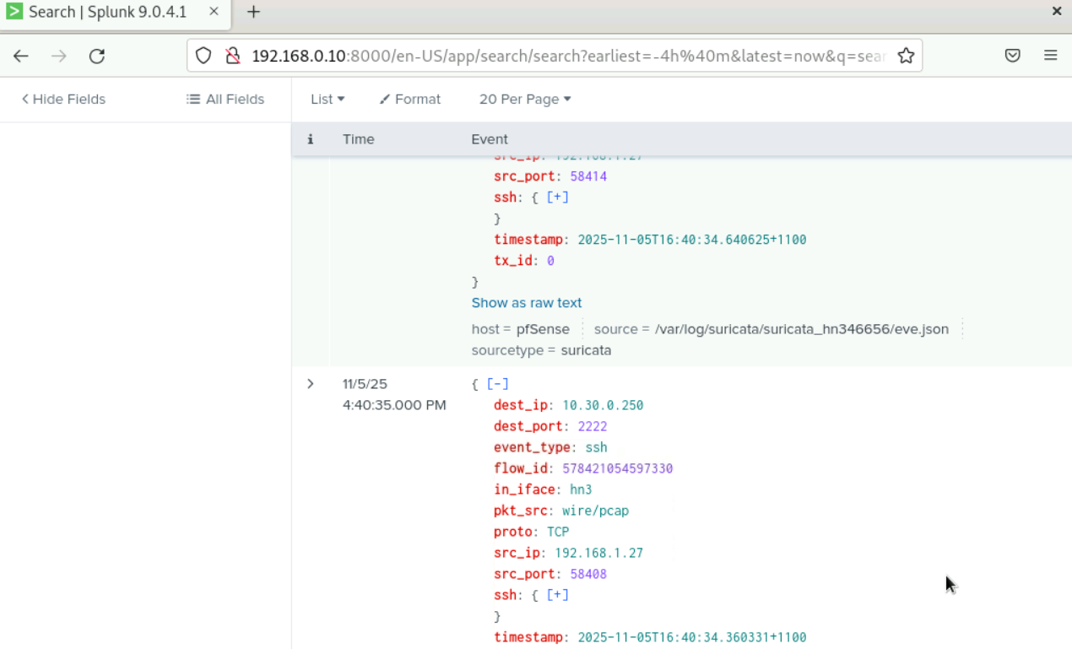

Using Wireshark and Splunk, we were able to monitor multiple login attempts to 10.30.0.250. It seems that the attacker finally logged into the system.

### 2.6 Post-Exploitation Enumeration

Red Team Activity:

The red team deployed *linpeas.sh* on the target Linux machine to assess its security posture and identify vulnerabilities or misconfigurations that could enable privilege escalation or system compromise.

Target: 10.30.0.250

Red team used a simple http server and uploaded linpeas.sh to the target machine as shown below.

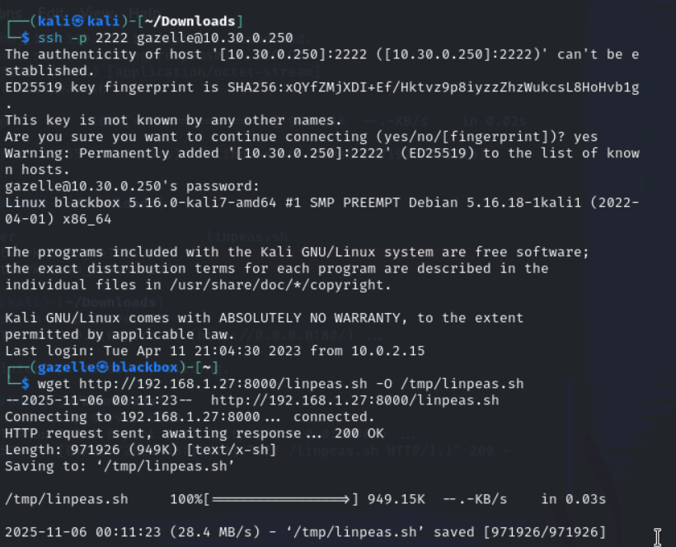

Then they run linpeas.sh

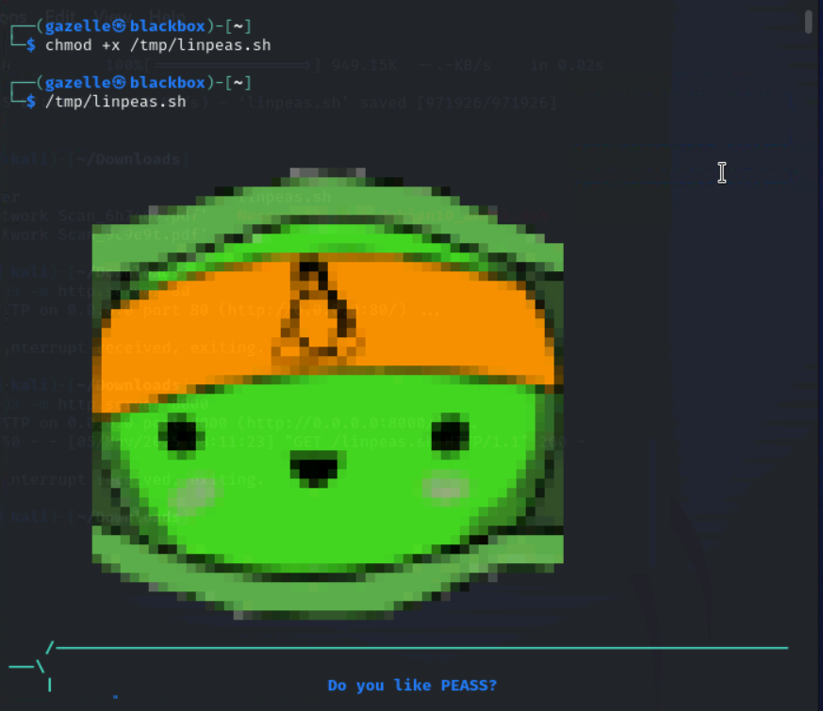

From the scanning result of linpeas.sh, the red team found that SUID was set on nano editor

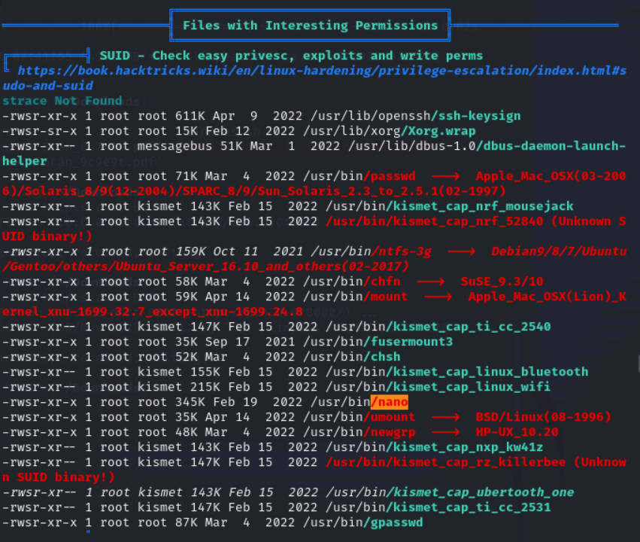

Blue Team Activity:

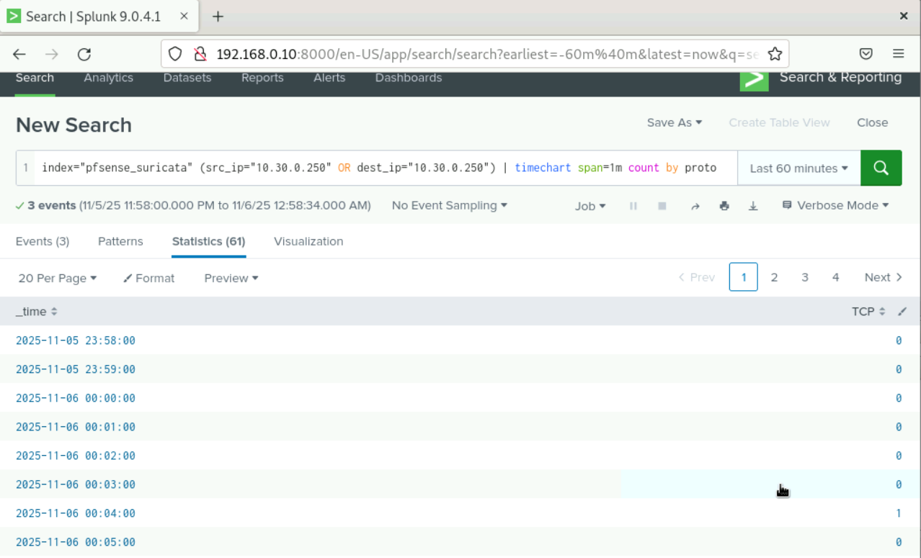

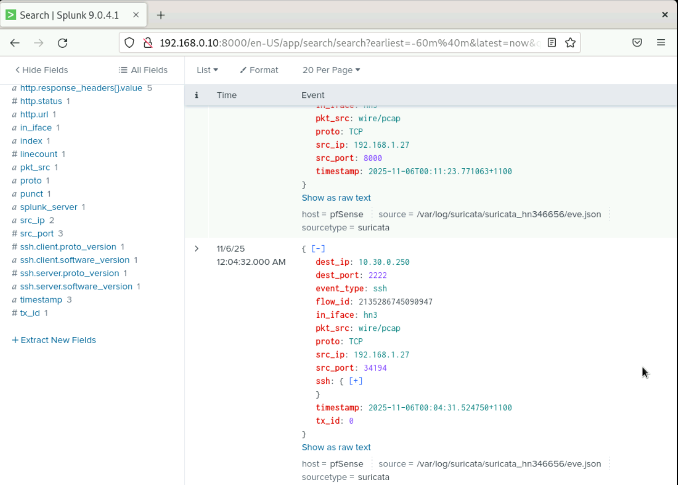

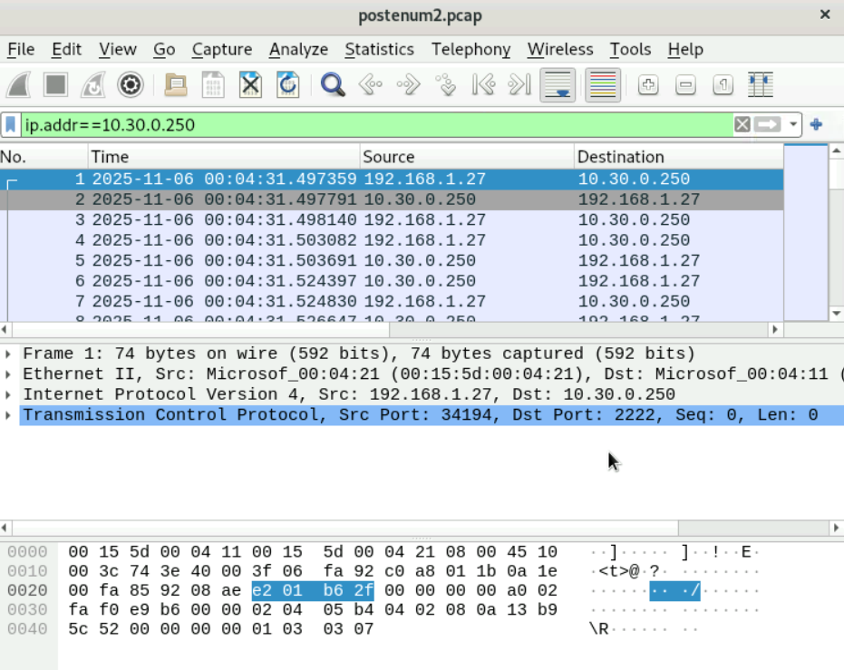

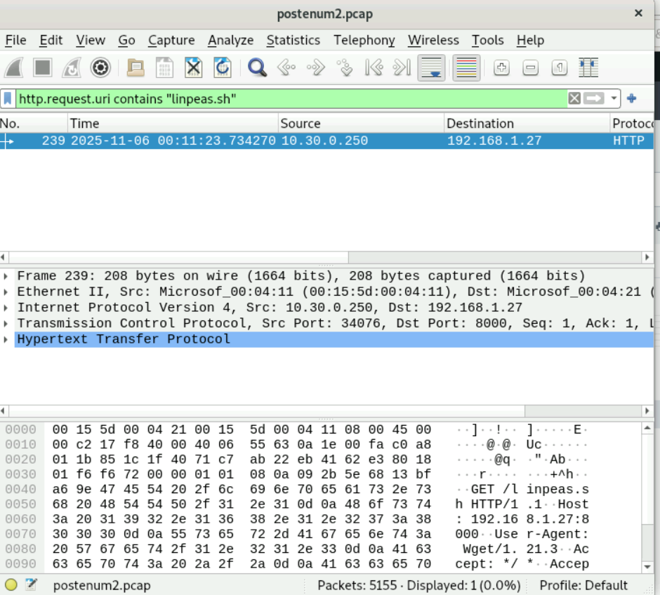

Using Splunk and Wireshark, we were able to monitor the incident and capture both Wget traffic and linpeas.sh enumeration.

### 2.7 Privilege Escalation

Red Team Activity:

Target: 10.30.0.250

Red team used SUID-enabled /bin/nano to edit /etc/passwd, created user 'demo' with password '123', and gained root access.

Generate a password hash as shown below:

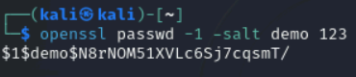

Edit /etc/passwd using nano.

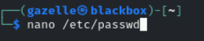

Add user 'demo' and password hash at the end. Save the file and exit.

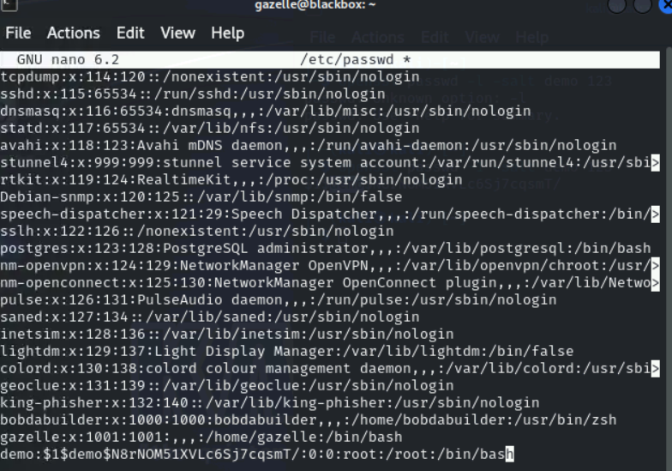

Switch the use from ‘gazelle’ to ‘demo’.

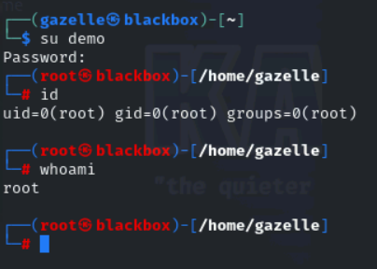

Now the red team gets root access to this Blackbox machine.

Blue Team Activity:

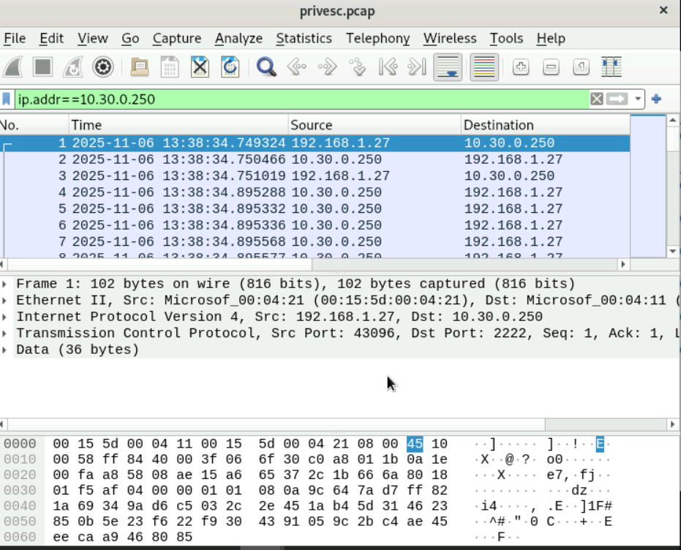

Using Wireshark, we could see attacker’s IP address at that time. Unfortunately, we failed to monitor this privilege escalation activity.

2.8 Blue Team Observation Checklist

Table 1 – Blue team observation checklist

|  |  |  |  |  |  |
| --- | --- | --- | --- | --- | --- |
| Time | Attack detected | Victim IP | Source IP | Description | Response |
| 03/11/2025  23:13:10 | Vulnerability Scanning | 10.30.0.235,  10.30.0.236,  10.30.0.237,  10.30.0.250 | 192.168.1.27 | Vulnerability Scanning to identify any know vulnerabilities on target hosts | Setting up IDS or WAF to monitor and block suspicious scanning. |
| 04/11/2025  14:25:41 | Port scanning | 10.30.0.250 | 192.168.1.27 | Port scanning to discover open ports on the target | Setting up IDS or WAF to monitor and block suspicious scanning. |
| 04/11/2025  22:56:51 | Directory Busting | 10.30.0.250 | 192.168.1.27 | Web content scanning to discover hidden web content | Setting up IDS or WAF to monitor and block directory requests. |
| 11/11/2025  22:49:05 | Spidering | 10.30.0.250 | 192.168.1.27 | Web spidering to map web application’s structure and find hidden items | Setting up IDS or WAF to monitor and block suspicious activities. |
| 05/11/2025  16:40:34 | Brute Force Attack | 10.30.0.250 | 192.168.1.27 | To gain unauthorized access to the target system by trying a large number of possible passwords in the dictionary | Setting up IDS or WAF to monitor for excessive failed login attempts and block suspicious IP addresses. |
| 06/11/2025  00:04:31 | Post- exploitation enumeration | 10.30.0.250 | 192.168.1.27 | To identify potential vulnerabilities or misconfigurations that could lead to privilege escalation or compromise | Treat the presence of linpeas.sh as a potential security incident. Initiate an incident response process. |
| 06/11/2025  13:38:34 | Privilege Escalation | 10.30.0.250 | 192.168.1.27 | To gain full access to the system | Blue team failed to monitor the activity |